March 16, 2023 – Thea Gregory 5291240 – Java Project report

Today I worked on the following:

* Created the database and tables for user, clients, and restaurants as a starting point
* Created the login view
* Created the login model
* Learned how to connect a mysql database to Java and have begun testing its functionality with the model and view.

Learning how to work with mysql in Java was an interesting exercise which fortunately didn’t take too much time. It did require some add-ons to Eclipse, but I found a website to walk me through that part.

I am happy with my progress. Working with mysql in Java was not as difficult as I’d feared, which was a nice change. The view looks good in my opinion, though my validation functions for username and password require testing. To finish off the day, I will create the login check function, which will enable me to test to see if a test user can login.

**Screenshots:**

Login screen:

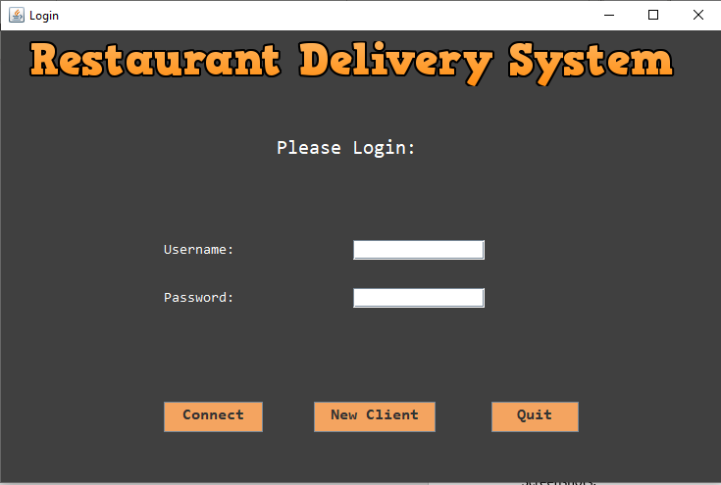

Login Model validation functions:

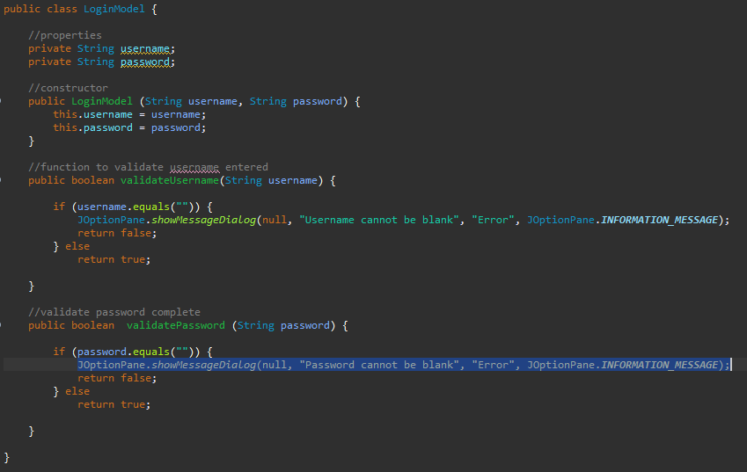

Database calls and actionlistener on connect button (a work in progress):

